CENWW-ODG 16 May 2018

MEMORANDUM FOR THE RECORD – 18 LGS 06 MFR Plugged Orifices

SUBJECT: Orifices 1A1 and 1A2 were discovered plugged on May 16 at approximately 04:30 am. We assume the orifice began to plug after it was last backflushed at 10:00 pm on May 15. Upon discovery, the orifices were immediately backflushed to remove debris. A total of 226 dead juvenile salmonids were collected on the separator due to this incident. Dead fish observations ceased once the orifice was cleared. Trash raking and VBS inspections are scheduled for May 29 and 30.

Little Goose experienced variable winds, spring runoff and increased debris loading during this time. Currently there is approximately 200 square feet of floating woody debris in the immediate forebay, inside the trash shear boom and boat barrier. Debris is shifting from the boat barrier (picture) into the area upstream of the powerhouse via wind and small saturated debris enters the juvenile bypass system.

Clipped Yearling Chinook | Unclipped Yearling Chinook | Clipped Steelhead | Unclipped Steelhead | Clipped  Coho | Unclipped Coho | Clipped Sockeye | Unclipped Sockeye | Total
136 | 50 | 3 | 1 | 1 | 20 | 14 | 1 | 226

- Species – Chinook salmon Oncorhynchus tshawytscha, Steelhead Oncorhynchus mykiss, Coho salmon Oncorhynchus kisutch and Sockeye salmon Oncorhynchus nerka.
- Origin – Hatchery and Wild
- Length – N/A
- Marks and tags – All fish were examined for PIT tags and coded wire tags (CWT) by ODFW and Anchor QEA employees. Of the 226 fish, 5 were marked with PIT tags (Table 1) and 19 were marked with CWT. Of the 19 marked with CWT, 15 were unclipped yearling chinook and 4 were unclipped coho salmon.
- Marks and Injuries found on carcasses – Some descaling was observed.
- Cause and Time of Death – Orifices 1A1 and 1A2 plugged with debris.
- Future and Preventative Measures – Project staff will continue to backflush orifices 5 times daily to ensure orifices remain free of debris for safe fish passage until further notice.

Table 1: Ptagis data query pertaining to PIT tagged fish mortalities related to orifice plug.
Tag ID | Wild/Hatchery | Species/Run/Rear | Marks
3DD.0077A8BE91 | Hatchery | Spring Chinook | AD
3DD.0077A91A45 | Hatchery | Spring Chinook | AD
3DD.0077A928AD | Hatchery | Spring Chinook | AD
3DD.0077B96F9E | Hatchery | Spring Chinook | AD
3DD.0077DACA65 | N/A | N/A | N/A

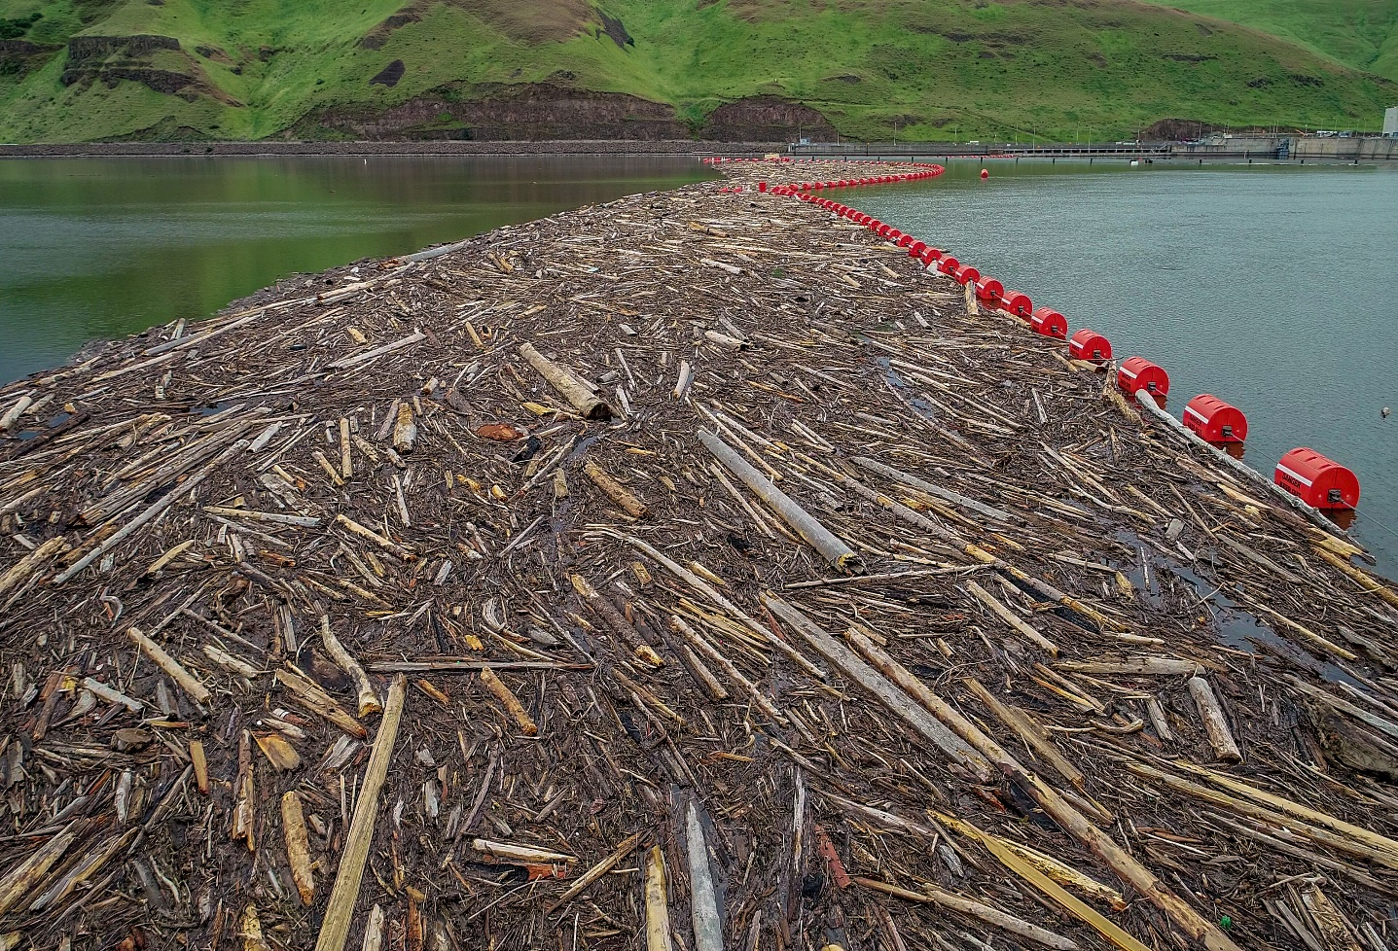

Sincerely,
Scott St. John
Project Fisheries Biologist
Little Goose Dam
(509) 399-2233 ext. 263
Scott.St.John@usace.army.mil

